Compile web portal page info on IPHI: description, role in project, logo

**Logo**

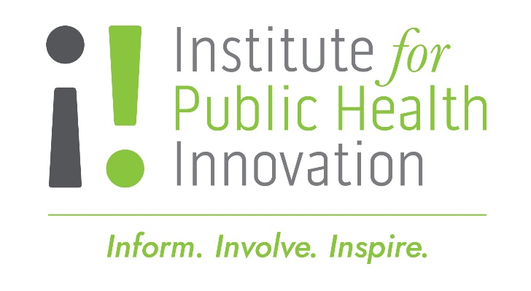

**Description**

The Institute for Public Health Innovation (IPHI) is a unique non-profit resource that builds partnerships across sectors and cultivates innovative solutions to improve health and well-being for all people and communities throughout the District of Columbia, Maryland, and Virginia. Our work strengthens health service systems and public policy; enhances the environments and conditions in which people live, age, work, learn, and play; and builds organizational and community capacity to sustain progress.

Formed in 2010, IPHI is one of 40-member public health institutes within the National Network of Public Health Institutes (NNPHI). Across the country, public health institutes are growing in number and have become an integral part of the nation’s public health infrastructure. Public health institutes work in conjunction with a myriad of public and private partners to protect and improve the public’s health, adding capacity for a range of functions from training to program development to research and evaluation. We are the official public health institute serving the District of Columbia, Maryland, and Virginia, and have quickly grown into an important partner at the state and local levels across the region.

**Project Role**

Institute for Public Health Innovation (IPHI) will train and certify project implementation partners on a standardized health literacy curriculum model/ approach. Develop and implement Health Literacy curriculum. IPHI will ensure that partners implement the training with fidelity, adapt curriculum, ensure training evaluation/audit, improvement, and reporting. These partners will also design and implement additional trainings for the cohort of partners as needed. IPHI will provide technical assistance to all partners geared towards improving health literacy training implementation and implement QI strategies.

Joanna suggestion: Institute for Public Health Innovation (IPHI) will train and certify project implementation partners on a standardized health literacy curriculum model/approach. The sessions will cover core elements of competency-based health literacy and topics relating to racial equity, cultural responsiveness, and trauma-informed care. Stronger2 training will occur over several weeks and involves extensive study in health literacy, trauma informed care, and program evaluation. Following training, the group will build and implement health literacy programs, with support from IHPI in the form of on-site Technical Assistance. Some of the key health topics that will be addressed in the health programming include COVID-19 vaccination, illness prevention, and health care decision making. Program participants will implement, share, and evaluate the results of their health programming. Program participants will also have the opportunity to discuss shared strategies and program best practices via a monthly Community of Practice, which IPHI will facilitate and lead.